Introduction

Goal
This document is to specify the test cases for verifying the functional requirements of DICOM Network Analyzer.

Scope
This document describes test cases for DICOM Network Analyzer, which captures the real time DICOM communication and analyzes offline captures. The tool is intended to be used by the DVTk team before Alpha/Beta release for verifying the basic functionality of DICOM Network Analyzer. The test cases should test the connectivity, interoperability capability.
Use the specified test data in test case for performing all the test use cases. Application may behave differently for different test data.

Sanity test cases

Test Case 1

Objective
Checking the DICOM Network Analyzer installation.

Pre-conditions
- .NET2.0 framework should be installed.
- DVTk definitions should be installed.

Actions

Action 1
Install the DICOM Network Analyzer using install shield DICOM Network Analyzer x_x_x.msi on non-development machine.

Action 2
Uninstall and again install the tool.

Expected result

Result 1
Check the presence of tool shortcut in start menu, Add/Remove programs and application folder in C:\Program Files\DVTk\ DICOM Network Analyzer.

Result 2
Check the absence of tool shortcut in start menu, Add/Remove programs and application folder in C:\Program Files\DVTk\ DICOM Network Analyzer after un-installation.

Test Case 2

Objective
Start up of the application.

Actions

Action 1
Run the application from start->Programs->DVTk->DICOM Network Analyzer.

Action 2
Try to minimize, maximize and resize the UI.

Action 3
Check the layouts and UI controls on tabs in Capture and Analysis mode.

Expected result

Result 1
The application should behave normally and display at least one network card for TCP/IP packet capturing.

Result 2
It should not crash. UI look & feel should not be affected by resizing.

Test Case 3

Objective
Sniffing the live DICOM communication by running tool on any of the network node.

Pre-conditions
DVT latest version with examples should be installed on the network node as mentioned by IP address.

Actions
Resources\Test Data\ Test DICOM file1.DCM
Resources\Test Data\ Test DICOM file2.DCM
Resources\Test Data\ Test DICOM file3.DCM

Action 1
Configure the IP address of other DICOM node in IP2 text box on DNA of other system. Press the ‘Start Capture’ toolbar button (Green triangle)/ Capture-> Start menu.

Action 2
Run DVT as Storage SCP emulator on IP1 node and send DICOM images as mentioned above through DVT Storage SCU emulator from local node where DNA is running.

Action 3
After capturing the packets for a DICOM association and press ‘Stop Capture’ toolbar button (Red rectangle)/ Capture-> Stop menu. Navigate to ‘Analysis’ mode form Mode->Analysis menu.

Action 4
Save the captured packets in a Capture (.cap) file from Menu item.

Action 5
Load the capture file saved in previous step.

Expected result

Result 1
View Association, PDUs details and Evaluation result on different tabs.

Result 2
Check the contents of different tabs with actual DICOM communication.

Result 3
Check the capture file saved on hard drive.

Result 4
Association, PDUs details should be same as in Result1. User can look for same validation results e.g. validation error and warnings.

Normal test cases

Test Case 4

Objective
Sniffing the live DICOM communication by running tool on third machine (Man in middle test scenario mentioned in chapter 4).

Pre-conditions
DVT latest version with examples should be installed on the network nodes as mentioned by IP addresses.

Actions
Resources\Test Data\ Test DICOM file1.DCM
Resources\Test Data\ Test DICOM file2.DCM
Resources\Test Data\ Test DICOM file3.DCM

Action 1
Configure both systems IP address in IP1 & IP2 textboxes on DNA. Run DNA on third machine i.e. System C (may be on laptop). Press the ‘Start Capture’ toolbar button (Green triangle)/ Capture-> Start menu.

Action 2
Run DVT as Storage SCP emulator on System A and send DICOM images as mentioned above through DVT Storage SCU emulator from System B.

Action 3
After capturing the packets for a DICOM association and press ‘Stop Capture’ toolbar button (Red rectangle)/ Capture-> Stop menu. Navigate to ‘Analysis’ mode form Mode->Analysis menu.

Action 4
Save the captured packets in a Capture (.cap) file from Menu item.

Action 5
Load the capture file saved in previous step.

Expected result

Result 1
View Association, PDUs details and Evaluation result on different tabs.

Result 2
Check the contents of different tabs with actual DICOM communication.

Result 3
Check the capture file saved on hard drive.

Result 4
Association, PDUs details should be same as in Result1. User can look for same validation results e.g. validation error and warnings.

Test Case 5

Objective
Evaluate all DICOM communication in a cap file.

Actions
Resources\Test Data\ test.cap

Action 1
Load the capture files mentioned in 12.2 in Analysis mode.

Action 2
Press Analysis-> Evaluate All DICOM Associations menu. Use Error, Warning, Backward & Forward toolbar button for browsing HTML report.

Expected result

Result 1
A separate UI should pop-up which will display the overview of all Associations with links to individual results for further browsing.

Result 2
Click and check detail/summary results per association.

Test Case 6

Objective
Checking saved DICOM objects exchanged between nodes.

Actions
Use the test data as mentioned in 10.2

Action 1
Load the capture files mentioned in 10.2 and check ‘dcm’ directory in the application folder.

Expected result

Result 1
All DICOM objects exchanged in a DICOM association should be saved per association.

Result 2
Open DCM files randomly in DICOM Eye tool. It should be a valid DICOM media file and contents of the DCM file should be consistent.

Test Case 7

Objective
Saving/Loading the configuration/setting (.setup) files.

Pre-conditions
Perform the test case 4.

Actions

Action 1
Save the current config by using File-> Setup File-> Save menu.

Action 2
Load the saved config file.

Expected result

Result 1
The following config info should be saved in XML config file.
  - IP Addresses
  - HTML Result Full File Name
  - Activity Log Full File Name

Result 2
The same setup/configuration should be loaded after loading the saved config file.

Test Case 8

Objective
Saving DICOM live stream in a capture file.

Pre-conditions
Perform the test case 4.

Actions

Action 1
Save the communication in a capture file by pressing File-> Capture File-> Save in capture file.

Expected result

Result 1
The saved capture file should open properly with Ethereal and Merge DPM.

Result 2
Check the content of cap file with Ethereal.

Exceptional and additional test cases

Test Case 9

Objective
Reading capture files of different supported format.

Actions
Resources\Test Data\ foute_worklist2.cap (Sun snoop capture file format)
Resources\Test Data\ abort.cap (winpcap format (NA sniffer (windows 1.1))

Action 1
Load the capture files as mentioned.

Expected result

Result 1
The capture file “foute_worklist2.cap” should open properly displaying below association and service elements:

10.163.95.73(34071)_10.163.95.42(3151)

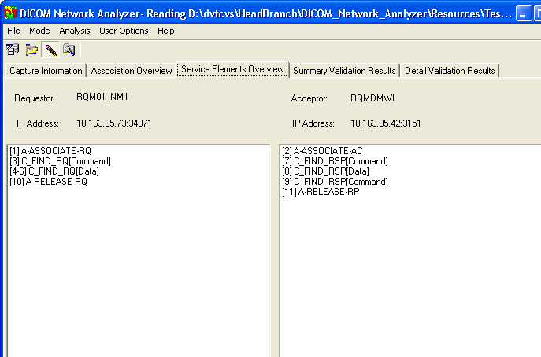

Result 2
The capture file “abort.cap” should open properly displaying below association and service elements:

192.168.100.247(4436)_192.168.100.63(6104)

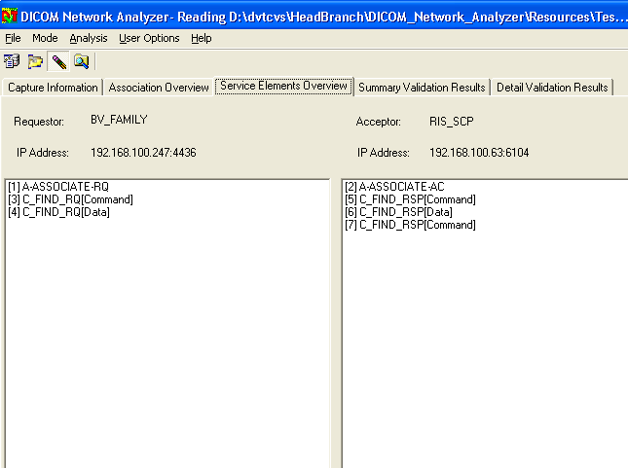

Test Case 10

Objective
Reading capture files from network drive, CD/DVD.

Actions
Resources\Test Data\ store_retreive_second_test.cap

Action 1
Load the capture file “store_retreive_second_test.cap” in Analysis mode.

Action 2
Load the capture file from CD/DVD.

Expected result

Result 1
The capture file should open properly without hang/crash and displaying all association and service elements (Only 3 screen shots are displayed for verification) as shown in screen shots:

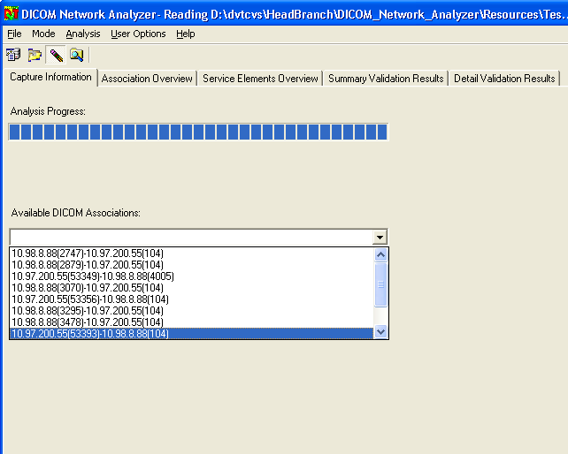

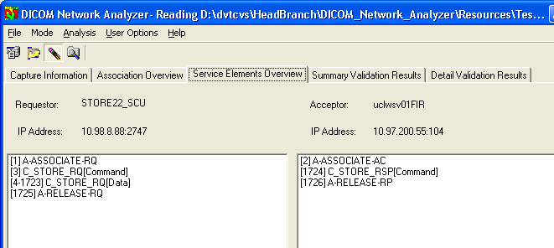

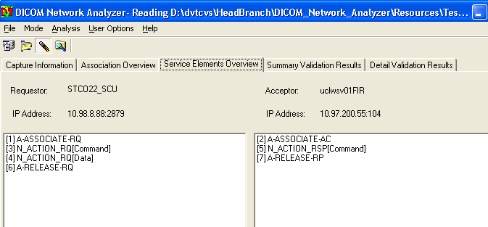

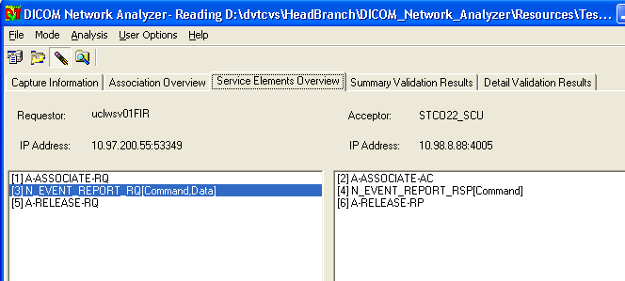

Test Case 11

Objective
Loading a very large capture file.

Actions
Resources\Test Data\ Sniffer_crash.cap
Resources\Test Data\ baddump.cap
Resources\Test Data\ capture-fail.cap

Action 1
Load the capture files mentioned.

Expected result

Result 1
The capture file “Sniffer_crash.cap” should open properly without hang/crash and displaying all association and service elements as displayed in screenshot.

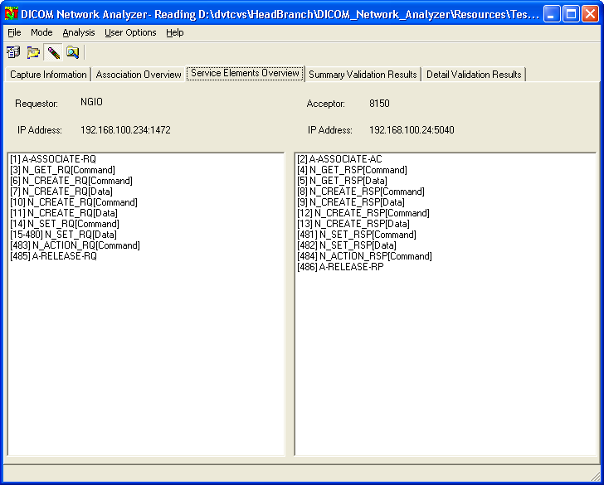

Result 2
The capture file “baddump.cap” should open properly without hang/crash and displaying all association and service elements as displayed in screenshot.
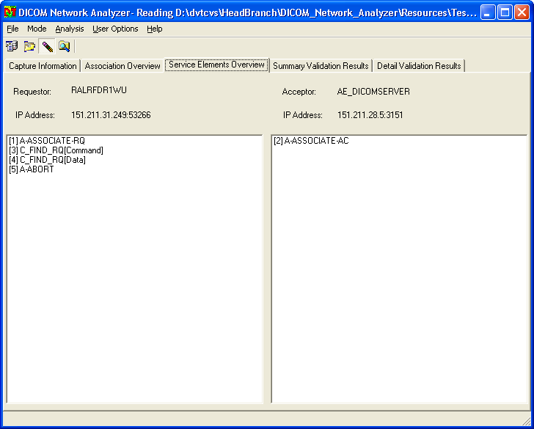

Result 3
The capture file “capture-fail.cap” should open properly without hang/crash and displaying all association and service elements as displayed in screenshots.

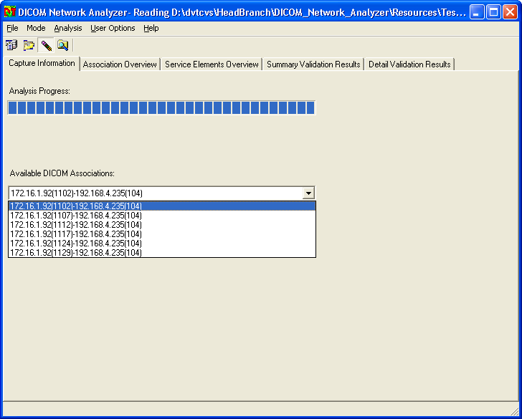

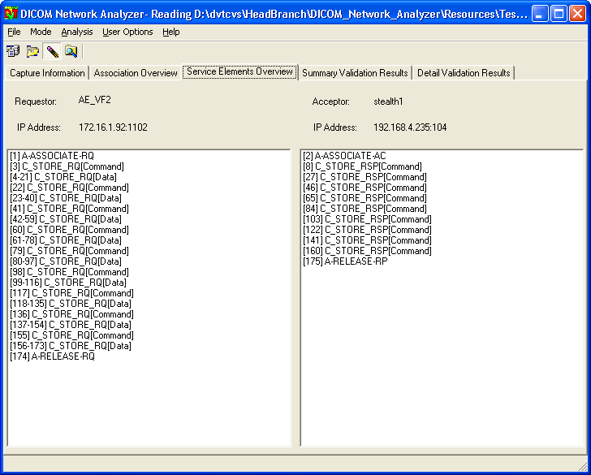

Test Case 12

Objective
Loading a capture file repeatedly e.g. 50 times.

Actions
Resources\Test Data\ test.cap

Action 1
Load the capture files mentioned.

Expected result

Result 1
Check if the memory usage does not increase drastically by keeping an eye on DNA process in Task manager.

Test Case 13

Objective
Loading a corrupt capture file.

Actions
Resources\Test Data\ baddump.cap
Resources\Test Data\ test.cap

Action 1
Load the first capture file mentioned.

Action 2
Load the second capture file mentioned.

Expected result

Result 1
DNA recognizes that it is a corrupt file by displaying “Incomplete byte stream” in result file.

Result 2
DNA is able to recover from this by again loading a normal capture file and see if all Dul and DICOM messages are present.

Man in the Middle Scenario
If System A and System B are connected via a HUB, any network packet that is send will be distributed to all system connected to that HUB. If for example a third system (the man in the middle) is connected and is running the DICOM Network Analyzer, it will be able to intercept all the network packets without System A and System B having any knowledge of it or being affected by this.
By default a Windows network card is only picking up the packets that are actually addressed to it. To let also the network card in windows pick up all the network packets, it needs to be in promiscuous mode.

